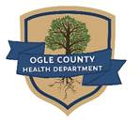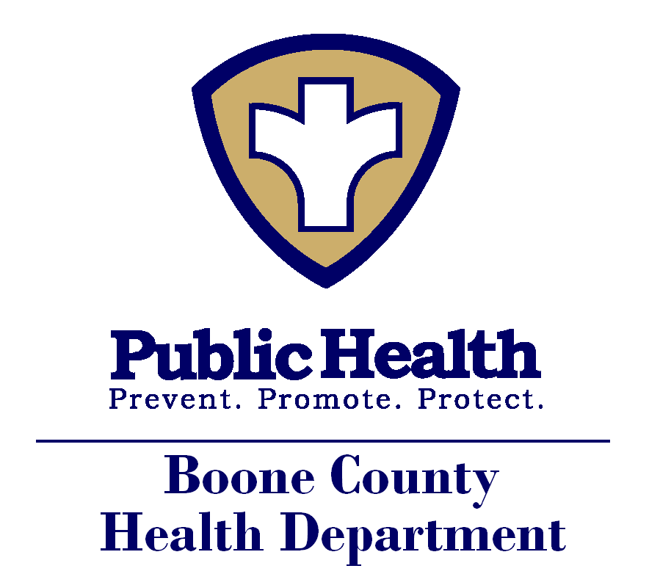****_

J O   D A V I E S S

C O U N T Y H E A L TH DEP A R T M E N T

## FOR IMMEDIATE RELEASE

Northern Illinois Rockford Region Public Information Officers

Media Contact: Katherine O’Toole, Media Liaison, 815-720-4213

March 13, 2020

**ADDITIONAL LOCAL HEALTH DEPARTMENTS**

**RECOMMEND SUSPENSION OF PUBLIC EVENTS**

WINNEBAGO COUNTY – Today, Lee County Health Department and Jo Daviess County Health Department join the Winnebago County Health Department (WCHD), Boone County Health Department, DeKalb County Health Department, and Ogle County Health Departments (LHDs) in recommending that businesses, institutions, and organizations suspend all public gatherings and events of 25 people or more until further notice. This recommendation was made as a precaution, and in an effort to prevent the spread of COVID-19 and reduce the risk of exposure. We do understand that this threshold may differ from community to community. This number was determined based on our local community considerations and with an abundance of caution.

This suspension includes large sporting events, fundraisers, concerts and performances, and many St. Patrick’s Day events including the Rockford’s St. Patrick’s Day parade. It does not include schools and childcare programs; government including polling places; healthcare and regular commerce that would occur at restaurants, grocery stores and other businesses. Social distancing in any situation is recommended.

Churches and faith based institutions are encouraged to follow guidance from the Centers for Disease Control and Prevention and are encouraged to maintain a contact list of those who attend each service.

As of right now, there are no confirmed cases of COVID-19 in the Northern Illinois Rockford Region, including Lee, Jo Daviess, Winnebago, Boone, Ogle, and DeKalb. The health and safety of our residents is our highest priority. “We want to do all we can to minimize the spread of this virus. Limiting public gatherings is a proven method of containing and minimizing the spread of disease. Here in Winnebago County, our priority is to limit public exposure and get back to normal public operations as quickly and safely as possible,” said Dr. Sandra Martell, director of the WCHD.

Further, these steps are being taken because this virus is highly contagious and because it’s a new virus the general population doesn’t have immunity to it. As there is no vaccine for the COVID-19 virus at this time, the best way to control the spread of the illness is to avoid exposure to it. While a majority of the people won’t become seriously ill from the virus, the most at risk include the older adults and those with underlying health conditions such as diabetes, heart disease and lung disease. As the situation evolves, your local health department will continue to work with the Illinois Department of Public Health and Centers for Disease Control and Prevention to take every effort possible to prevent illness from spreading.

Due to the vulnerability of the population in long-term care facilities, we are also restricting visitors to long term care facilities except in certain circumstances, such as end of life. Employees of long term care facilities will be screened before they start their shift.

Additionally, we recommend that you consider community spread in areas you may travel to before you go and adjust your plans accordingly.

The number of confirmed cases in Illinois continues to increase, and current information suggests that person-to-person spread will continue to occur and more cases will be identified in Illinois. Our goal is to reduce the impact of COVID-19, by minimizing transmission and protect the health and safety of our community.

The public can help prevent the spread of COVID-19 by:

* Staying home and isolating yourself from others in your home if you’re sick
* Practicing good hand washing
* Covering your sneeze and/or cough
* Cleaning frequently touched services

**If a community resident has symptoms of COVID-19 (fever, cough, shortness of breath), call your healthcare provider, urgent care clinic or the emergency department BEFORE you visit.**

If the public has questions about COVID-19, they can call the Illinois Department of Public Health hotline:

* 1(800) 889-3931
* DPH.SICK@ILLINOIS.GOV

When there is a confirmed case of COVID-19 in our community, the local health departments will inform the community.

###